**INTRODUCTION**

Now a days we released the importance of the natural resources and as we were seriously trying to preserve them effectively. As we can’t be careful all the time we can alternatively use the present technology to build the smart systems. These smart systems can help use to remind things at the time we need. As result we are going to take the task of water control system in building. Here firstly, we are going to control the water flow in the apartment by using the rate of inflow and the outflow of the water in the tank. We are going to calculate the rate of inflow and rate of outflow in the tank. If the rate of inflow is greater than the rate of outflow the level of the water in the tank increases and if the rate of inflow is lesser than the rate of outflow, then the level of the water in the tank is going to be decreased. We are going to have a display in the tank the level in the front panel we can clearly understand what’s going on in the tank. And we are also adding the additional feature to the program by showing the led and alarm. If the water level is less than 10 liters, then red led and alarm will be ringing. If the water level is filled up, then if it reaches the 90 liters also a green led is on. The inputs and the outputs both can be displayed in the front panel. The inputs can be changed randomly. We will have two exception cases like water level becoming less than zero and the water level becoming more than 1000 liters, these two cases can be controlled by cutting the range to 0 and 1000 in the cases. i.e., if the water level is less than or equal to zero then the fixed value zero will be displayed in the tank as water level can’t be zero. In the same way if the water level reaches more than the 1000 liters then it will be fixed to 1000 liters as a result we can come out of the two error cases.

The major tasks were the calculation of the water level in the tanker and displaying the level based on the output the increment and decrement of the water in the tank. The final front panel will show the water level in the tank, a rate of inflow and rate of outflow. The inputs we are taking are the rate of flow of water into the tank and the rate of the water flowing out of the tank. The output is the water level indication in the tank. Additionally, we are going to see the display of the led and alarm sound based on the water level in the tank, because it makes our task more clear and easier. The improvements of our project are it can be automated and if the water level is below 10 liters then automatically the switch need to be on and if the water level reached the 90 liters then it should automatically get off along with the manual switches to control.

**METHODOLOGY:**

This prototype is designed using the following steps

**2.1 Description on adapted method:**

Here in our project we are going to select the method in which we are going to get the sound alarm and the LED light glowing as the required output. The manual switching mechanism is used here. But we can get the alarm ad led display automatically when the water level is less than 10 per and greater than the 90 along with the alarm sound. The major tasks were the calculation of the water level in the tanker and displaying the level based on the output the increment and decrement of the water in the tank. The final front panel will show the water level in the tank, a rate of inflow and rate of outflow. The inputs we are taking are the rate of flow of water into the tank and the rate of the water flowing out of the tank. The output is the water level indication in the tank. Additionally, we are going to see the display of the led and alarm sound based on the water level in the tank, because it makes our task more clear and easier. The improvements of our project are it can be automated and if the water level is below 10 liters then automatically the switch need to be on and if the water level reached the 90 liters then it should automatically get off along with the manual switches to control. We will have two exception cases like water level becoming less than zero and the water level becoming more than 1000 liters, these two cases can be controlled by cutting the range to 0 and 1000 in the cases. i.e., if the water level is less than or equal to zero then the fixed value zero will be displayed in the tank as water level can’t be zero. In the same way if the water level reaches more than the 1000 liters then it will be fixed to 1000 liters as a result we can come out of the two error cases. As the display shows the major part of the program and the output of the whole program display is very important. As we can’t be careful all the time we can alternatively use the present technology to build the smart systems. These smart systems can help use to remind things at the time we need. As result we are going to take the task of water control system in building. Here firstly, we are going to control the water flow in the apartment by using the rate of inflow and the outflow of the water in the tank.

**2.2 Description of flow of Program with flow chart:**

*TWO NUMERIC CONTROLS AND ONE NUMERIC INDICATOR*

*CALUCLATION OF INFLOW AND OUTFLOW OF WATER*

*DISPLAY THE WATER LEVEL BASED ON THE RATE OF INFLOW AND OUTFLOW*

BASED ON THE LEVEL OF WATER INDICATION WITH LED AND ALARM

*INDICATION OF THE WATER LEVEL USING TANK IN THE FRONT PANEL*

*VERIFICATION OF THE RATE OF FLOW AND TANK LEVEL*

**Structures and Elements used in the design process:**

1. Numeric control

2. Case structure

3. While loop

4. Booleans (stop button, LED)

5. Mathematical operators (equal to, multiplication, addition, subtraction)

6. Tank

**TECHNICAL DESCRIPTION:**

1. NUMERIC CONTROL

The **Numeric Control** is a input display which by default is a **numeric** double

value and can modified using the up and down arrows next to the display or manually changed by double clicking and inputting the desired value. The **Numeric** Indicator is an output display which will display the value that it receives.

2. CASE STRUCTURE

Case structure contains one or more sub diagrams, or cases, exactly one of which executes when the structure executes. The value wired to the case selector determines which case to execute.

Contains one or more sub diagrams, or cases, exactly one of which executes when the structure executes. The value wired to the case selector determines which case to execute.

|  |  |
| --- | --- |
|  | **Selector label**—Displays the value(s) for which the associated case executes. You can specify a single value or a [range of values](lvhowto.chm::/case_selector_values.html). You also can use the selector label to [specify a default case](lvhowto.chm::/Specify_Default_Case.html). |
|  | **Sub diagram(case)**—Contains the code that executes when the value wired to the case selector matches the value that appears in the selector label. To modify the number or order of sub diagrams, right-click the border of the Case structure and select the appropriate option. |
|  | **Case selector**—Selects which case to execute based on the value of the input data. The input data can be a Boolean, string, integer, enumerated type or [error cluster](lvhowto.chm::/Using_Case_Structures_for.html). The data type you wire to the case selector determines the allowed cases you can enter in the selector label. |

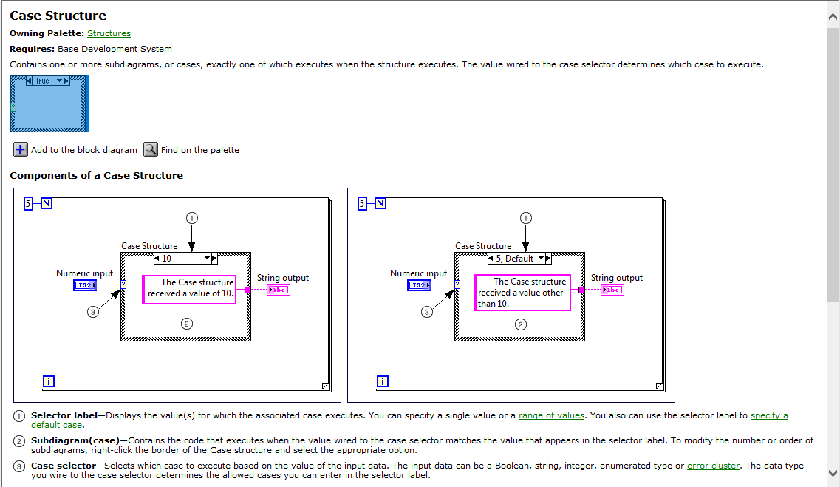

3.WHILE LOOP:

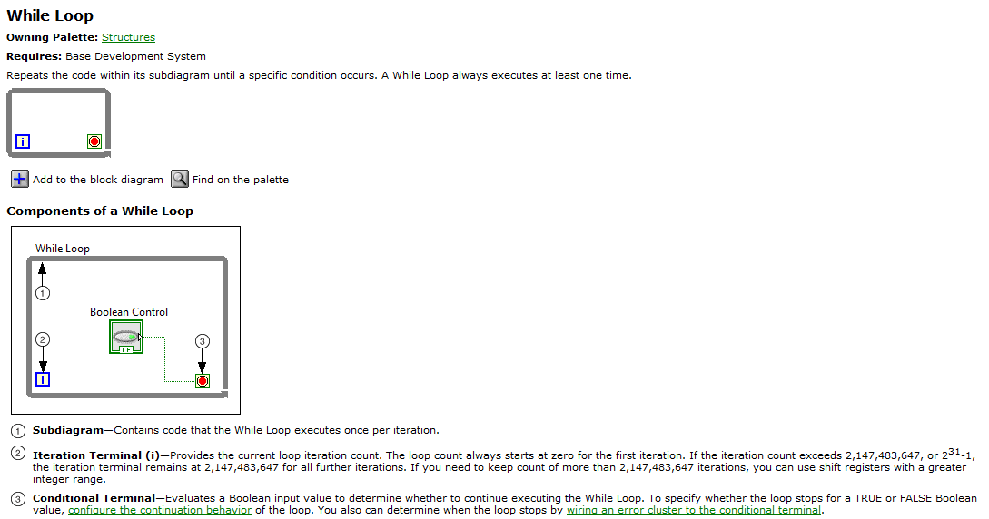

**Experiment and Results**

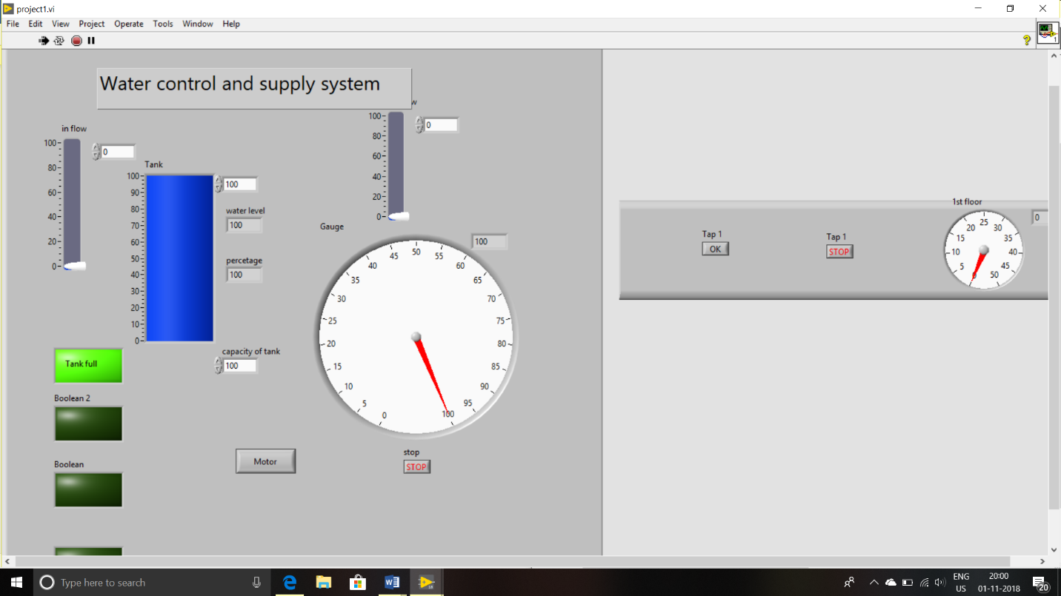

when tank is totally filled green light is glowed and gauge reading is 100.

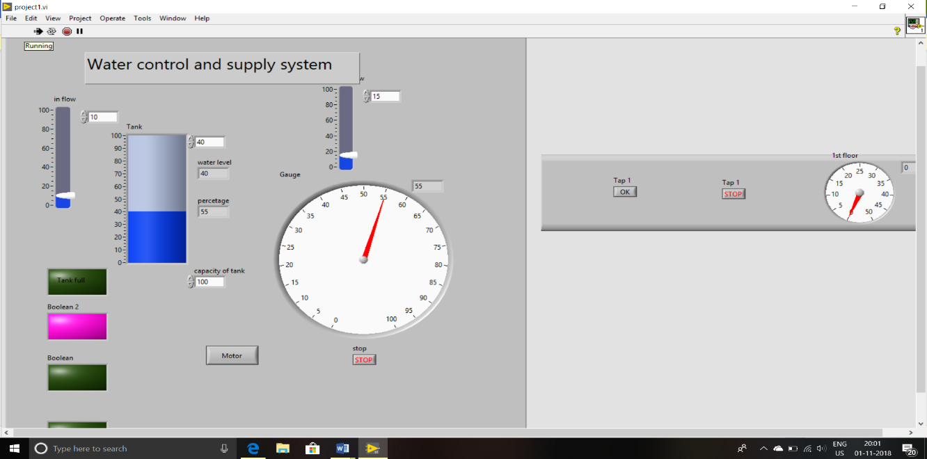

When tank level is in between 50 to 90 pin light is glowed and percentage is shown in led display and gauge

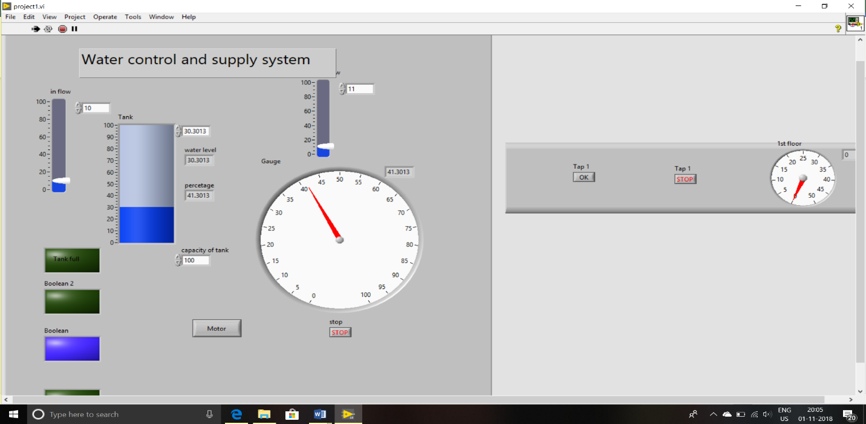

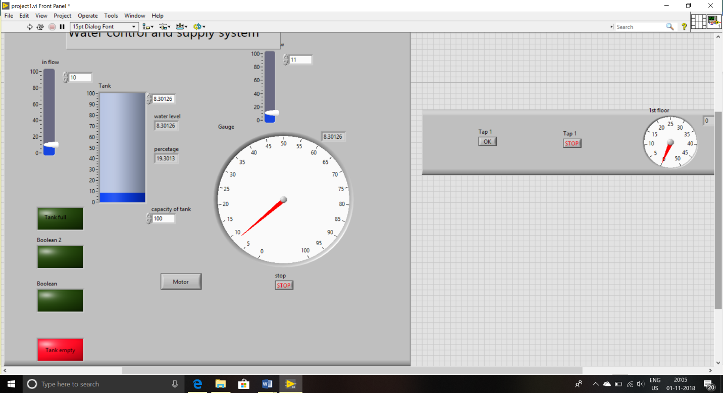When reading is in between 20 to 50 blue light is glownand the reading is shown I led display and gauge.

When tank level is lessthan 20% the red light is glown and buzzer will be on. And reading is shown in gauge.

**5. Conclusion and Future Scope:**

Water is one of the most important basic needs for all living beings. But unfortunately, a huge amount of water is being wasted by uncontrolled use. Other water level monitoring systems do exist but lack functionality in terms of being able to monitor and manage multiple sources of water. LabVIEW is ideal for any measurement or control system, integrating graphical tools that facilitate the building of a wide range of applications in less time compared to using other practices. The present system modelling and implementation paradigm can be easily migrated to water management in many different types of environments. The system provides a remote physical interface which provides all necessary data. The system executes the task continuously and without human intervention. In case of failure, manual control of the system can be carried out.